Bayesian Network Modelling Workshop

Team Neo

EBAC 4 (Part Time), Institute of Systems Science, NUS

[e0146864, e0146946, e0147017, e0146771] @u.nus.edu

Abstract

This work is part of assignment to build a Naïve Bayes network + one other Bayesian network and then compare the results. We decided to use the Tree Augmented Naïve Bayes for the comparison.

# Executive Summary

Our business problem is to build and compare Bayesian network prediction models to predict the likely injury level for vehicle occupants. Initially, the dataset was checked for missing values. Since, we found a considerable amount of missing values, they were imputed using kNN imputation method in R. Later, all the variables were analyzed for their correlation and the highly correlated variables were removed. We decided to build the **Naïve Bayes** model using R and also Genie. To accomplish the comparison, we also performed **Tree Augmented Naïve Bayes** on the dataset using Genie software. In both the models K-fold (5) cross validation was done for model validation.

Our key findings are:

1. Though we expected TAN to outperform Naïve Bayes but with the current data, the TAN probabilistic models **performed slightly better** than Naïve Bayes. [compared based on Genie output for both to avoid any margin of error due to tools. R output was for exploration only and not used in the analysis]
2. Both the models are good in predicting Minor to Moderate injuries. But have low accuracy to predict critical injuries.
3. Confusion Matrix for Naïve Bayes[1] and TAN[2]
4. If the car comes with safety Bag and it was deployed during accident, 76% chances are there that the injury will be Minor (Class 1) [3]
5. For the highest level of injury with maximum death probability, we found that majority of the vehicles involved are between 1400 – 2000 Kgs of weight, Speed limit was between 45-60.
6. For the critical injuries, even if 73% of the times bag was deployed. This implies that safety bag deployment is not the only factor in controlling the injury level.

# Data Description

The dataset was collected from Bayesian website, containing **21 variables** and approx. **20,500 observations**, **16** are **numerical variables** and **5** are **categorical variables.** However, at the later stage of data preprocessing, we binned numerical data into different categories based on range value.

**Table 1:** Variable Description

|  |  |  |  |  |
| --- | --- | --- | --- | --- |
| **S.No.** | **Name** | **Description** | **Variable type** | **Data Type** |
| 1. | GV_CURBWGT | Vehicle curb weight | Explanatory | Numerical |
| 2. | GV_DVLAT | Lateral component of Delta V | Explanatory | Numerical |
| 3. | GV_DVLONG | Longitudinal component of Delta V | Explanatory | Numerical |
| 4. | GV_ENERGY | Energy absorption | Explanatory | Numerical |
| 5. | GV_LANES | Number of Lanes | Explanatory | Numerical |
| 6. | GV_MODELYR | Vehicle model year | Explanatory | Numerical |
| 7. | GV_OTVEHWGT | Weight of the other vehicle | Explanatory | Numerical |
| 8. | GV_SPLIMIT | Speed limit | Explanatory | Numerical |
| 9. | GV_WGTCDTR | Truck weight code | Explanatory | Categorical |
| 10. | OA_AGE | Age of Occupant | Explanatory | Numerical |
| 11. | OA_BAGDEPLY | Air Bag System Deployed | Explanatory | Categorical |
| 12. | OA_HEIGHT | Height of Occupant | Explanatory | Numerical |
| **13.** | **OA_MAIS** | **Maximum known Occupant AIS** | **Response** | **Categorical** |
| 14. | OA_MANUSE | Manual belt system use | Explanatory | Numerical |
| 15. | OA_SEX | Occupant's Sex | Explanatory | Categorical |
| 16. | OA_WEIGHT | Occupant's Weight | Explanatory | Numerical |
| 17. | VE_GAD1 | Deformation Location | Explanatory | Categorical |
| 18. | VE_PDOF_TR | Clock Direction for Principal Direction of Force | Explanatory | Numerical |
| 19. | GV_FOOTPRINT | Vehicle Footprint | Explanatory | Numerical |
| 20. | VE_ORIGAVTW | Average Track Width | Explanatory | Numerical |
| 21. | VE_WHEELBAS | Vehicle Wheel Base | Explanatory | Numerical |

# Data Selection and Preprocessing

We followed the following process to analyze the dataset:

**Figure 1**: Process to Explore the data

## Tools Used

* **R** – Used for Data exploration, imputation using kNN, Naïve Bayes modeling
* **Genie** – Naïve Bayes and Tree Augmented Naïve Bayes Network Modeling and Analysis

## Dealing with missing values

* 1. **Filling up missing Values in Numerical variables with kNN imputation in R**: To proceed further, all the missing values were replaced with imputed values using k-Nearest Neighbour Imputation based on a variation of the Gower Distance for numerical, categorical, ordered and semi-continuous variables. It generates multiple imputations for incomplete multivariate data. A small piece of code has been written in R to implement imputation on numerical data.

**Table** shown below summarizes the **key statistical indicators** of the attributes that have been imputed. The **Original dataset** and **Imputed dataset** have the almost the **same Mean, Median** and **standard deviation** after imputation:

**Table 2:** Imputed Dataset

|  |  |  |  |  |  |  |  |  |  |
| --- | --- | --- | --- | --- | --- | --- | --- | --- | --- |
|  |  | **Original Dataset** | | | | **Imputed Dataset** | | | |
| **S. No** | **Variables** | **Rows** | **Mean** | **Standard**  **Deviation** | **Median** | **Rows** | **Mean** | **Standard**  **Deviation** | **Median** |
| 1 | GV_CURBWGT | 20204 | 1617.26 | 393.57 | 1530 | 20247 | 1618 | 391.6 | 1530 |
| 2 | GV_DVLAT | 14049 | 0.04 | 13.02 | 0 | 20247 | 0.05 | 13 | 0 |
| 3 | GV_DVLONG | 14049 | -14.76 | 17.66 | -15 | 20247 | -14.97 | 18.66 | -16 |
| 4 | GV_ENERGY | 14049 | 505.24 | 645.74 | 306 | 20247 | 495.2 | 657.6 | 291 |
| 5 | GV_LANES | 20244 | 3.28 | 1.36 | 3 | 20247 | 3.28 | 1.23 | 3 |
| 6 | GV_MODELYR | 20247 | 2003.62 | 2.77 | 2003 | 20247 | 2004 | 2.89 | 2003 |
| 7 | GV_OTVEHWGT | 18147 | 1630.16 | 411.35 | 1550 | 20247 | 1626 | 411.4 | 1550 |
| 8 | GV_SPLIMIT | 20016 | 40.73 | 11.24 | 40 | 20247 | 40.73 | 11.14 | 40 |
| 9 | OA_AGE | 20190 | 40.17 | 17.37 | 37 | 20247 | 40.16 | 18.1 | 37 |
| 10 | OA_HEIGHT | 17508 | 170.84 | 10.75 | 170 | 20247 | 171 | 9.89 | 170 |
| 11 | OA_MAIS | 19203 | 0.91 | 1.04 | 1 | 20247 | 0.89 | 1 | 1 |
| 12 | OA_MANUSE | 19774 | 0.88 | 0.32 | 1 | 19774 | 0.8847 | 0.21 | 1 |
| 13 | OA_WEIGHT | 17599 | 78.72 | 19.64 | 77 | 20247 | 78.42 | 17 | 77 |
| 14 | VE_ORIGAVTW | 20014 | 154.75 | 7.66 | 154 | 20247 | 154.8 | 8 | 154 |
| 15 | VE_WHEELBAS | 20238 | 281 | 28.72 | 272 | 20247 | 282 | 28.63 | 281 |
| 16 | VE_PDOF_TR | 18298 | 152.62 | 67.51 | 135 | 20247 | 152.5 | 67 | 135 |

## 3.2 Correlation Check Of Numerical Values

The second step is to analyze the **multi-collinearity effects** in between the numerical variables and **eliminate the highly-correlated** variables from the analysis of **Naive Bayes**. Data analysis tool in Excel has been used to compute the correlation matrix using **Pearson’s coefficient** and for better interpretation, the results have been compiled in a correlation chart. Please find below the correlation matrix among all numeric variables:

**Table 3:** Correlation Matrix

|  |  |  |  |  |  |  |
| --- | --- | --- | --- | --- | --- | --- |
|  | GV_CURBWGT | GV_DVLAT | GV_DVLONG | GV_ENERGY | GV_LANES | GV_MODELYR |
| GV_CURBWGT | 1.00000 | 0.00409 | 0.00900 | 0.08131 | 0.00803 | 0.06757 |
| GV_DVLAT | 0.00409 | 1.00000 | -0.00546 | -0.06049 | -0.10239 | -0.01338 |
| GV_DVLONG | 0.00900 | -0.00546 | 1.00000 | -0.29869 | 0.01331 | 0.01759 |
| GV_ENERGY | 0.08131 | -0.06049 | -0.29869 | 1.00000 | -0.02264 | -0.00658 |
| GV_LANES | 0.00803 | -0.10239 | 0.01331 | -0.02264 | 1.00000 | 0.01223 |
| GV_MODELYR | 0.06757 | -0.01338 | 0.01759 | -0.00658 | 0.01223 | 1.00000 |
| GV_OTVEHWGT | 0.02627 | -0.00625 | 0.00483 | 0.07214 | 0.00074 | 0.05581 |
| GV_SPLIMIT | 0.05182 | -0.05526 | -0.02968 | 0.09981 | 0.09140 | -0.01599 |
| OA_AGE | 0.08409 | 0.02679 | 0.04399 | -0.00560 | -0.02206 | 0.05710 |
| OA_HEIGHT | 0.15703 | 0.00544 | -0.02349 | 0.04305 | 0.00048 | 0.00020 |
| OA_MAIS | -0.06111 | 0.05023 | -0.22317 | 0.36677 | -0.03903 | -0.06091 |
| OA_MANUSE | -0.01087 | 0.02307 | 0.13011 | -0.09956 | 0.01255 | 0.04177 |
| OA_WEIGHT | 0.15777 | 0.02171 | -0.01403 | 0.05077 | -0.00903 | 0.02259 |
| VE_ORIGAVTW | **0.79453** | 0.01123 | 0.01491 | 0.08015 | 0.00685 | 0.14398 |
| VE_WHEELBAS | **0.76721** | 0.00939 | -0.01268 | 0.09766 | 0.00124 | 0.01535 |
| VE_PDOF_TR | -0.03066 | -0.43379 | 0.53289 | 0.01352 | 0.07727 | 0.03074 |
| GV_FOOTPRINT | **0.81796** | 0.01090 | -0.00484 | 0.09804 | 0.00170 | 0.06008 |

|  |  |  |  |  |  |  |  |  |  |  |  |
| --- | --- | --- | --- | --- | --- | --- | --- | --- | --- | --- | --- |
|  | GV_OTVEHWGT | | GV_SPLIMIT | OA_AGE | | OA_HEIGHT | | OA_MAIS | | OA_MANUSE | |
| GV_CURBWGT | 0.02627 | | 0.05182 | 0.08409 | | 0.15703 | | -0.06111 | | -0.01087 | |
| GV_DVLAT | -0.00625 | | -0.05526 | 0.02679 | | 0.00544 | | 0.05023 | | 0.02307 | |
| GV_DVLONG | 0.00483 | | -0.02968 | 0.04399 | | -0.02349 | | -0.22317 | | 0.13011 | |
| GV_ENERGY | 0.07214 | | 0.09981 | -0.00560 | | 0.04305 | | 0.36677 | | -0.09956 | |
| GV_LANES | 0.00074 | | 0.09140 | -0.02206 | | 0.00048 | | -0.03903 | | 0.01255 | |
| GV_MODELYR | 0.05581 | | -0.01599 | 0.05710 | | 0.00020 | | -0.06091 | | 0.04177 | |
| GV_OTVEHWGT | 1.00000 | | 0.04748 | 0.00465 | | -0.00106 | | 0.08593 | | -0.02962 | |
| GV_SPLIMIT | 0.04748 | | 1.00000 | -0.00969 | | 0.03886 | | 0.09343 | | 0.00954 | |
| OA_AGE | 0.00465 | | -0.00969 | 1.00000 | | -0.04131 | | 0.09509 | | 0.07422 | |
| OA_HEIGHT | -0.00106 | | 0.03886 | -0.04131 | | 1.00000 | | -0.03024 | | -0.06326 | |
| OA_MAIS | 0.08593 | | 0.09343 | 0.09509 | | -0.03024 | | 1.00000 | | -0.18441 | |
| OA_MANUSE | -0.02962 | | 0.00954 | 0.07422 | | -0.06326 | | -0.18441 | | 1.00000 | |
| OA_WEIGHT | 0.00037 | | 0.03518 | 0.13197 | | 0.47439 | | 0.05822 | | -0.08692 | |
| VE_ORIGAVTW | 0.03137 | | 0.03973 | 0.11018 | | 0.14532 | | -0.06106 | | 0.00680 | |
| VE_WHEELBAS | 0.02830 | | 0.05776 | 0.07753 | | 0.18233 | | -0.04687 | | -0.03264 | |
| VE_PDOF_TR | 0.03690 | | 0.14054 | 0.00270 | | -0.00421 | | -0.07389 | | 0.04353 | |
| GV_FOOTPRINT | 0.03011 | | 0.05565 | 0.09005 | | 0.18049 | | -0.05424 | | -0.02295 | |
| Contd.. | **OA_WEIGHT** | **VE_ORIGAVTW** | | | **VE_WHEELBAS** | | **VE_PDOF_TR** | | **GV_FOOTPRINT** | |
| GV_CURBWGT | 0.15777 | **0.79453** | | | **0.76721** | | -0.03066 | | **0.81796** | |
| GV_DVLAT | 0.02171 | 0.01123 | | | 0.00939 | | -0.43379 | | 0.01090 | |
| GV_DVLONG | -0.01403 | 0.01491 | | | -0.01268 | | 0.53289 | | -0.00484 | |
| GV_ENERGY | 0.05077 | 0.08015 | | | 0.09766 | | 0.01352 | | 0.09804 | |
| GV_LANES | -0.00903 | 0.00685 | | | 0.00124 | | 0.07727 | | 0.00170 | |
| GV_MODELYR | 0.02259 | 0.14398 | | | 0.01535 | | 0.03074 | | 0.06008 | |
| GV_OTVEHWGT | 0.00037 | 0.03137 | | | 0.02830 | | 0.03690 | | 0.03011 | |
| GV_SPLIMIT | 0.03518 | 0.03973 | | | 0.05776 | | 0.14054 | | 0.05565 | |
| OA_AGE | 0.13197 | 0.11018 | | | 0.07753 | | 0.00270 | | 0.09005 | |
| OA_HEIGHT | 0.47439 | 0.14532 | | | 0.18233 | | -0.00421 | | 0.18049 | |
| OA_MAIS | 0.05822 | -0.06106 | | | -0.04687 | | -0.07389 | | -0.05424 | |
| OA_MANUSE | -0.08692 | 0.00680 | | | -0.03264 | | 0.04353 | | -0.02295 | |
| OA_WEIGHT | 1.00000 | 0.15558 | | | 0.18668 | | -0.00706 | | 0.18684 | |
| VE_ORIGAVTW | 0.15558 | 1.00000 | | | **0.73978** | | -0.02582 | | **0.87237** | |
| VE_WHEELBAS | 0.18668 | **0.73978** | | | 1.00000 | | -0.03040 | | **0.96653** | |
| VE_PDOF_TR | -0.00706 | -0.02582 | | | -0.03040 | | 1.00000 | | -0.03035 | |
| GV_FOOTPRINT | 0.18684 | **0.87237** | | | **0.96653** | | -0.03035 | | 1.00000 | |

**Figure 2:** Correlation Matrix in R

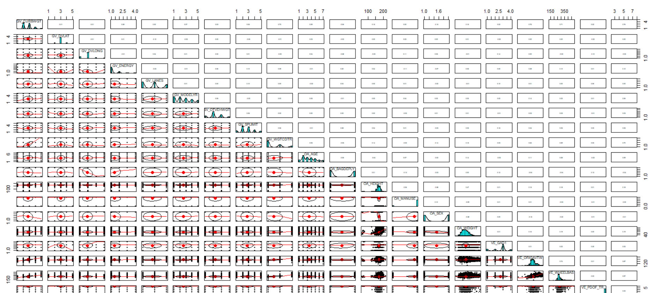

The results of **correlation matrix** show that **GV_CURBWGT, GV_FOOTPRINT, VE_ORIGAVTW** and **VE_WHEELBAS** have **high correlation** among themselves. Hence, we decided to keep the **GV_CURBWGT** and eliminate the rest of the variables.

# Feature Engineering

Before proceeding with classification using Bayesian networks, we used Range values to **bin** the continuous variable in R.

**Table 4:** Variables Binning

|  |  |  |  |
| --- | --- | --- | --- |
| **Variable** | **Datatype** | **No. of Bins** | **Binning Methodology** |
| GV_WGTCDTR | Categorical | 3 | Already categorized in dataset |
| OA_BAGDEPLY | Categorical | 2 | Already categorized in dataset |
| OA_SEX | Categorical | 2 | Already categorized in dataset |
| VE_GAD1 | Categorical | 4 | Already categorized in dataset |
| OA_MAIS | Categorical | 4 | Intuitive, divided into 4 injury levels |
| GV_MODELYR | Numerical | 5 | Intuitive, uniform distribution of years |
| GV_CURBWGT | Numerical | 5 | Binning based on range using R |
| GV_DVLAT | Numerical | 5 | Binning based on range using R |
| GV_DVLONG | Numerical | 4 | Binning based on range using R |
| GV_ENERGY | Numerical | 4 | Binning based on range using R |
| GV_LANES | Numerical | 3 | Intuitive, division of lanes |
| GV_OTVEHWGT | Numerical | 4 | Binning based on range using R |
| GV_SPLIMIT | Numerical | 5 | Binning based on range using R |
| OA_AGE | Numerical | 7 | Binning based on range using R |
| VE_PDOF_TR | Numerical | 6 | Binning based on range using R |

The details of binning process of different numerical variables is described below:

|  |  |
| --- | --- |
|  |  |
| **OA_MAIS (Class Variable)** | Divided in to:   * **Minor injury:** Class 0 and Class 1 (negligible probability of death) * **Moderate Injury:** Class 2 (less probability of death (1-10%)) * **Severe Injury:** Class 3 and Class 5 (medium probability of death (5-50%)) * **Death:** Class 5 and Class 6 (No chance of Survival) |
| **GV_WGTCDTR** | Divided in to: ‘**Passenger Car**’, ‘**Truck (<=6000 lbs.)**’ and ‘**Truck (<=10000 lbs.)**’ |
| **OA_BAGDEPLY** | Divided into ‘**Deployed**’ and ‘**Not Deployed**’ |
| **OA_SEX** | Divided into ‘**Male’** and ‘**Female**’ |
| **VE_GAD1** | Separate groups are created for ‘**Left**’, ‘**Right**’, ‘**Rear**’ and ‘**Front**’ |
| **GV_MODELYR** | Separate groups are created for cars manufactured before 2002, between 2002 and 2008 and post 2008 |
| **GV_CURBWGT** | Separate groups are created for vehicle below 800 kg, between 800 to 1400 kg, between 1400 to 2000 kg, between 2000 to 2600 kg and more than 2600 kg |
| **GV_DVLAT** | Separate groups are created for speed: less than -20 kmph, between -20 to 0 kmph, between 0 to 20 kmph and more than 20 kmph |
| **GV_DVLONG** | Separate groups are created for speed less than -20 kmph, between -20 to 0 kmph, between 0 to 20 kmph and more than 20 kmph |
| **GV_ENERGY** | Separate groups are created for values less than 600, between 600 to 1200, between 1200 to 1800 and more than 1800 |
| **GV_LANES** | Separate groups are created for values less than 3, between 3 to 5 and more than 5. |
| **GV_OTVEHWGT** | Separate groups are created for values less than 1000, between 1000 to 1500, between 1500 to 2000 and more than 2000 |
| **GV_SPLIMIT** | Separate groups are created for values less than 30, between 30 to 45, between 45 to 60 and more than 60 |
| **OA_AGE** | Separate groups are created for values less than 25, between 25 to 35, between 35 to 50, between 50 to 60 and more than 60 |
| **VE_PDOF_TR** | Separate groups are created for values less than 25, between 25 to 35, between 35 to 45, between 45 to 55 and more than 55 |

# Model Building

While the business problem is to build and compare the Bayesian networks to predict likely injury level of the vehicle occupants, we used both **“R”** and **Genie** to build Naïve Bayes model, and **only** **Genie for Tree Augmented Naïve Bayes(TAN)**. Output in **“R”** were not in line with Genie output. Hence, we decided to compare both the models based on Genie output only. “R” algorithm serves as an extended learning to build Naïve Bayes programmatically.

## Naive Bayes Model (Implemented Using R)

The Naive Bayes model is a special form of Bayesian network. This model is mainly used for classification problems. The important feature of Naive Bayes model is that, it has very strong independence assumptions. The final dataset **after imputation** and **binning** is used for modelling.

### Training and Validation Set

In a k-fold cross validation, the original data set is divided into k equal parts. Out of those k-parts, one part of the dataset is used for validation and the remaining k-1 parts are used for training the classifier. This process is repeated k-times and each of the parts is used as validation data, exactly once.

The advantage of this method is that it ensures each instance in the dataset is used both, as a training and validation sample and every instance is used exactly once as a validation sample.

Here, 4-fold cross validation has been used as shown in figure below:

**Figure 3:** 5-Fold Cross Validation

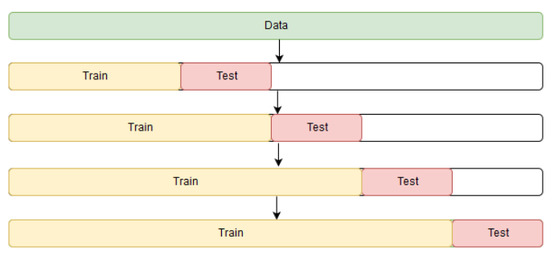

### Accuracy

1. Overall accuracy being **82.6%** while the accuracy of individual classes has been shown in the confusion matrix below.

### Confusion Matrix

1. The model can predict the minor injuries and moderate injury with good accuracy and has low accuracy for predicting deaths.
2. **Table 5:** Confusion Matrix

|  |  |  |  |  |
| --- | --- | --- | --- | --- |
| Prediction | 1 | 2 | 3 | 4 |
| Minor (1) | 4829 | 362 | 219 | 37 |
| Moderate (2) | 122 | 28 | 43 | 3 |
| Severe (3) | 138 | 58 | 93 | 25 |
| Death (4) | 45 | 18 | 37 | 17 |

## Naive Bayes Model (Implemented Using Genie)

The same dataset as prepared for R has been used in this model to compare the network within the same tool periphery as TAN to make sure R apis are not influencing the results due to unforeseen default values.

### Network developed in Genie

The network is as show below:

**Figure 4:** Network in Genie

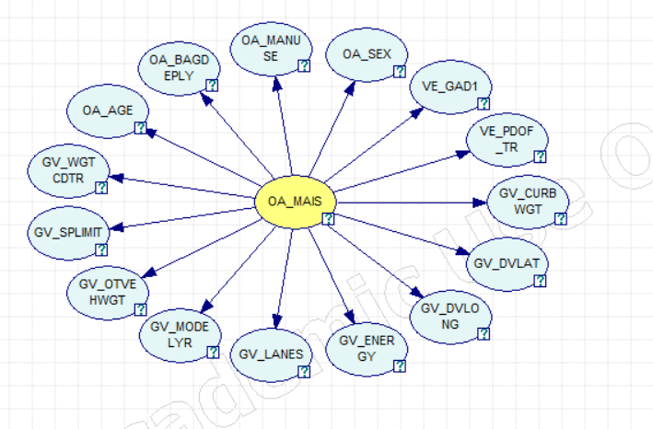

### Training and Validation Set

5-fold Cross validation approach was used for training and validating the model.

### Results

5-fold validation process was used in Geniei -> validate network option and shown **accuracy of 83.79%** overall. The model is found to be predicting the moderate and death prediction well but not minor (class 1) and Severe (class 3).

**Figure 5:** Accuracy shown in Genie

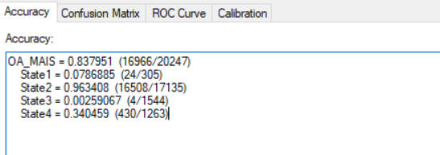

### Confusion Matrix

As we can see the State 3 (class 3) has very less representation. This shows signs of data balancing issue and hence our model seems to be overfitted. To overcome this issue oversampling will be recommended to increase the representation of classes with less values. Overall State2 which is **Moderate injury** is predicted with high accuracy. This class has 1-10% of death chance.

**Figure 6:** Confusion Matrix

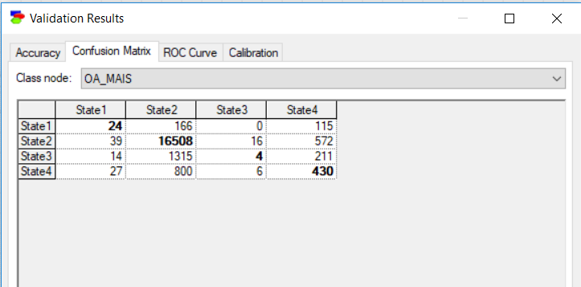

### ROC Curves

Based on the ROC curve, we can see that area of curve for State1, State2, and State4 is good shows the high accuracy of tests for these states.

**Figure 7:** ROC Curves

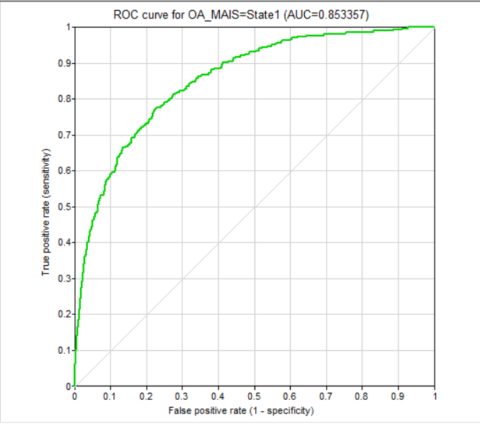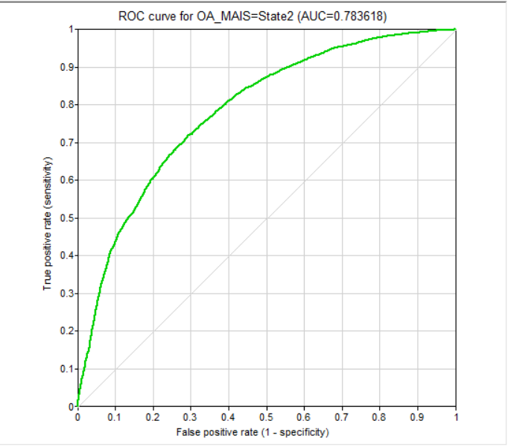

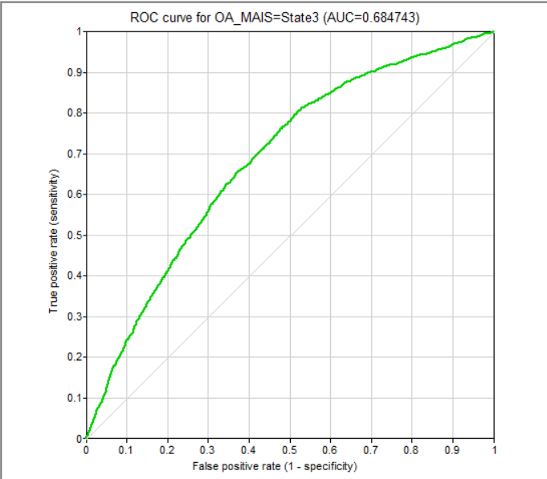 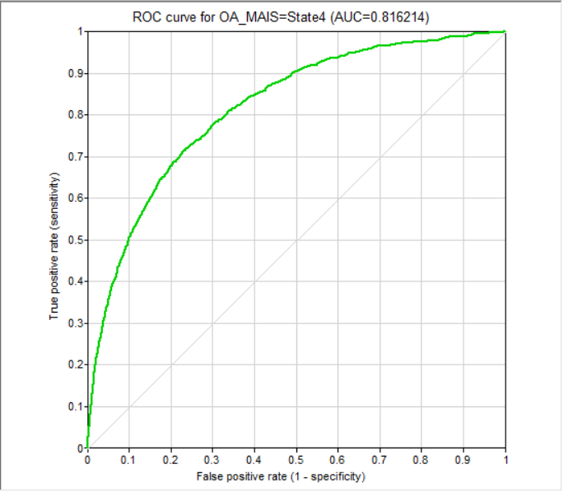

## TAN Model (Implemented Using Genie)

To compare the performance of Naïve Bayes we built Tree Augmented Naïve Bayes network using Genie. Data used was same as processed above using R.

### Training and Validation Set

Same 5-fold validation process used.

### Results

As shown below, we have used **95% confidence interval** for the validation.

**Figure: 8 –** Validation Results GENIE Tool

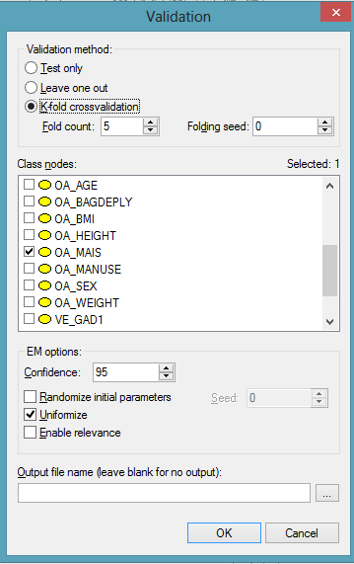

### Accuracy

We could achieve overall accuracy of **84%**. Individual class prediction accuracy is as shown below.

**Figure 9:** Validation Results

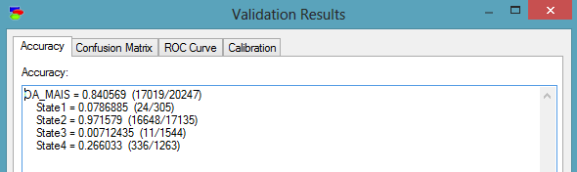

### Confusion Matrix

Below figure shows confusion matrix:

**Figure 10:** confusion Matrix TAN

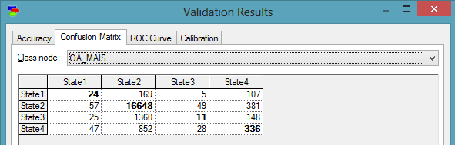

### ROC Curve

Below figure shows the ROC curve for the TAN model for each class. Graph shows the trade-off between the rate at which something is predicted correctly with the rate of False positive rate

**Figure 11:** ROC Curve

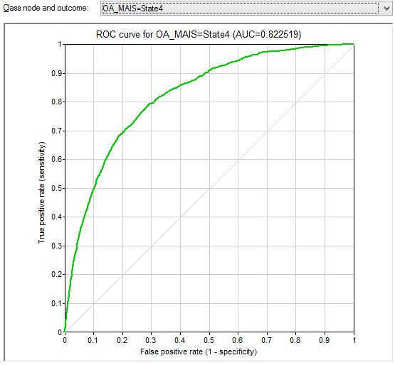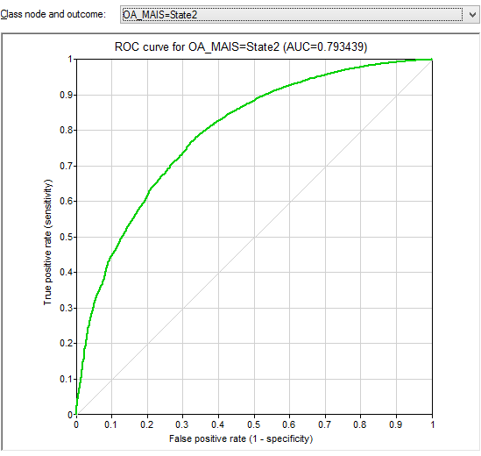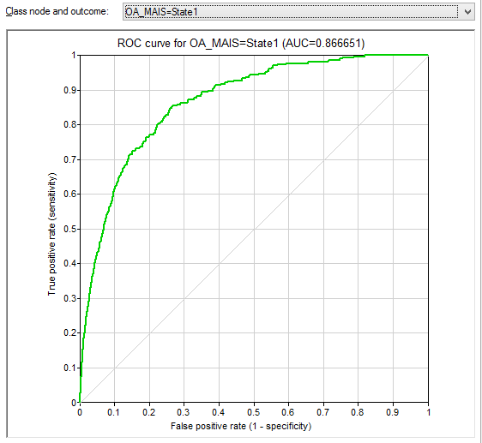 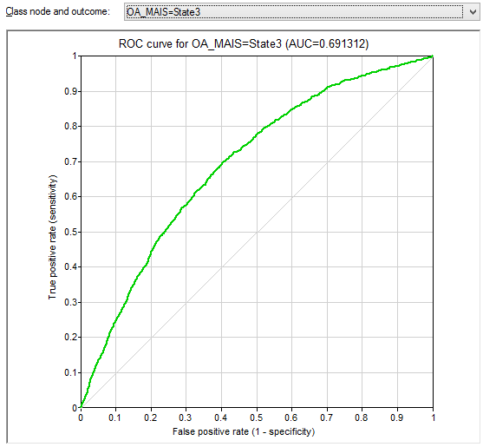

# Further Network Analysis

## Bag Deployed Vs Not Deployed

If the safety bag was deployed during accident, it is found that **76% chances** is for the injury be in State 1 which is Minor injury. This reinforce the idea that every vehicle should be equipped with safety bag.

**Figure 12:** Update Belief based on Evidence – Bag Deployed

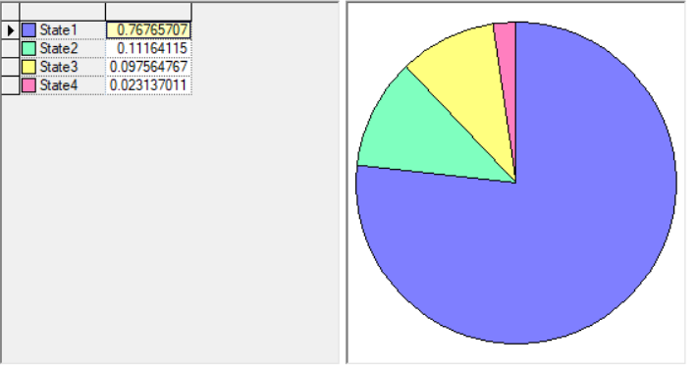

# References

* Lecture Notes
* Online Learning resources